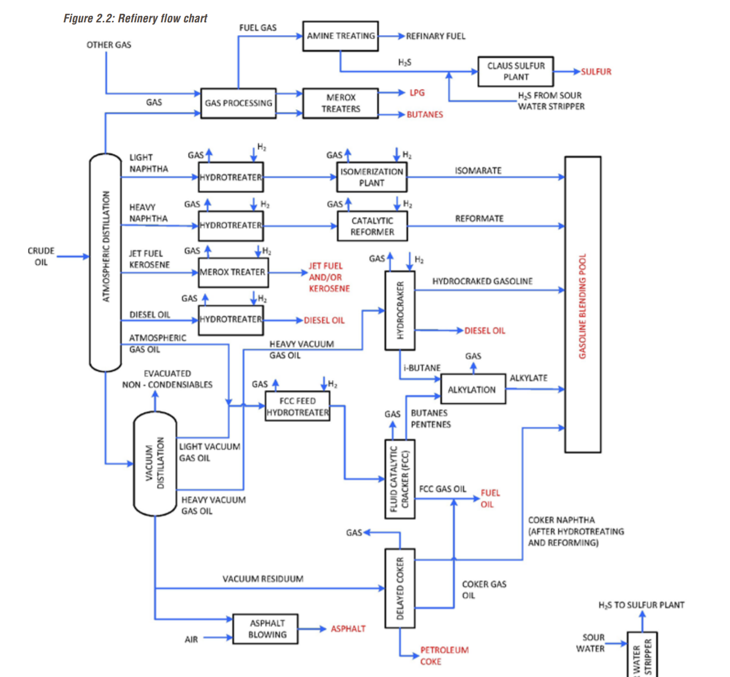

Questions:

* Are hydrotreaters vital for Isomerizaton plant and refomers?
* Regarding below units, is there some units more common in the US, such as FCCs ?
* Seasonality in refineries (max jet…) ?
* Petrochemical plants: Splitters/aromatics/olefin installations ?

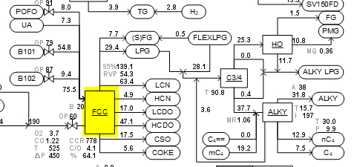**FCC/FCCU:** Fluid Catalytic Cracking is a unit mainly used in the US. The FCC is one of the biggest unit to create Gasoline. HCN (heavy catalytic naphtha) produced by the FCC is one of the main component of Gasoline (around 35%) .

**Scanfiner:** decrease the sulfur % from the product coming out of the FCC

**Hydrotreater:** decrease the sulfur of the LVN and HVN before going into the Isomerization plant or Reformer.

**Alkylation**: Convert isobutane, propene, butane into alkylate (high octane gasoline component) 12% of the gasoline composition.

**Reformer:** HVN to create LPG and reformate (high octane values and also benzene ) 30% of the gasoline composition.

**Isomerisation plant:** LVN to create Isomerates (Paraffinic and contains no benzene, aromatics or sulfur) 5% of the gasoline composition.

**Steamcracker:** Feedstock can be LPG (Propane, Butane…) or Naphtha (LVN) to create Ethylene and TAR. Depending on the price of Jet it can also be used as feedstock for the steamcracker. At Exxon we are going to try in sep to use some Jet as feedstock in the steamcracker. LPG in winter is expensive so Naphtha is the main feedstock in winter for the steamcracker.

**Coker/Hydrocracker:** creates mainly distillates using some LSVGO/HSVGO. Hydrocrackers are mainly used in Europe because of their production of Diesel. Exxon recently built a hydrocracker plant in Rotterdam.

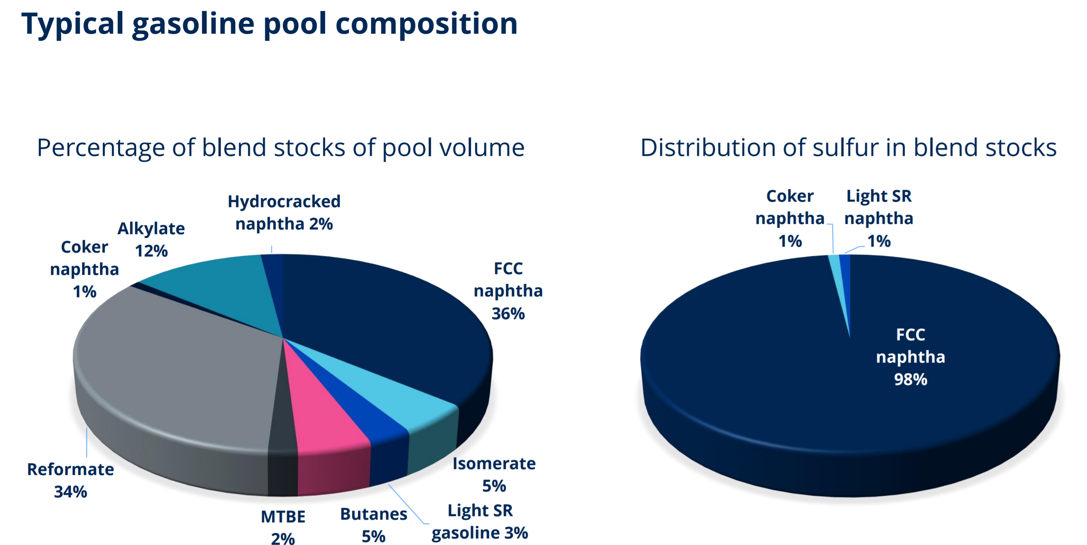

GDO= EBOB/RBOB.Tthe TA arb is driven by :

* Freight
* Mogas/Naphtha spread because of the blending.
* RIN. If RIN goes up RBOB goes up
* Cash premiums

RIN= ticket traded when a batch of renewable (DC, SG, Advance) is made. An Ethanol plant is producing RINs for instance. RVO is the volume of renewable fuels that has to be meet for each refineries are importers of gasoline in the US.

Mogas/Naphtha: Mogas is driven by E5 and Naphtha by Open Spec

Average cash diff ( cell C4) is the average from beginning of the month to today